Problem Set -01
Duration: 8 am – 4 pm.

The main objective of this day is to understand your capability in problem solving. All program must be done using Console C# application. At first, you will do the dry coding using pen and paper and after that implement your thoughts using C#.(We encourage your google search for any kind of problem solving or error fixing)
Happy problem solving☺

- Write hello world program in C# program.
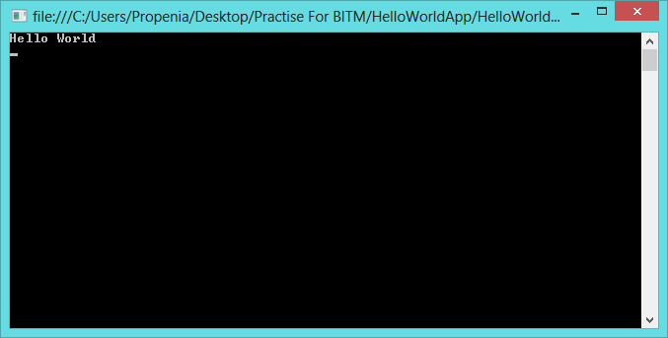
- Take two numbers from user and show their addition, subtraction, division and multiplication result in console.

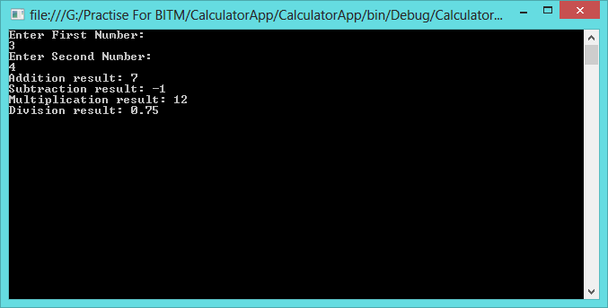

- Take two numbers from user and tell which one is bigger and which one is small. If they are equal tell that they are equal.
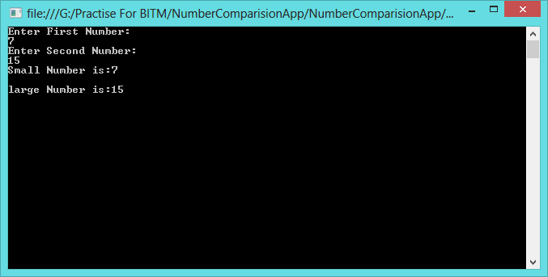
- Take user name as input and show a greeting like: Hi, <user name> good day.
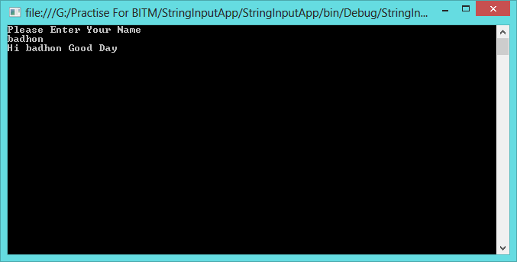

- Show number from 1 to 100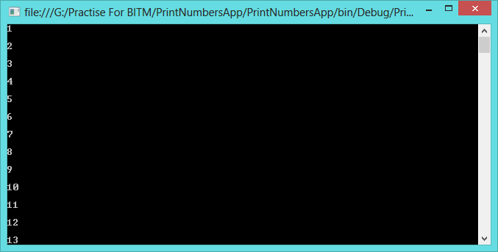
- Take upper and lower limit from user and show all integers between them (including them).
- Show all even number from 1 to 100
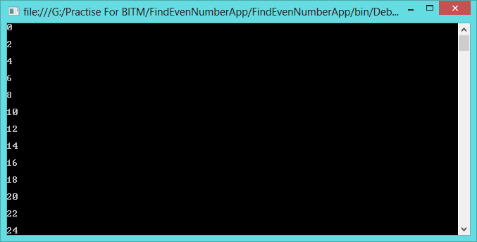
- Show first 100 Fibonacci number.
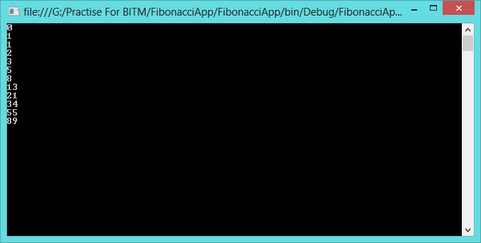
- What is windows registry? Read a show all windows registry using a C# program.
Help: i.http://en.wikipedia.org/wiki/Windows_Registry
ii. http://www.codeproject.com/Articles/3389/Read-write-and-delete-from-registry-with-C

- What is the format CSV file?
- What is environmental variable? Show all environmental variables and their value in C#.
Help:i. http://msdn.microsoft.com/en-us/library/1h5xxewc(v=vs.110).aspx
ii. http://en.wikipedia.org/wiki/Environment_variable

- What is event log in windows OS? See all event viewers in windows 8. Write a CSharp program to show eventlog in windows
- Find all services running in windows. Write a program using C# to view all the running services in your windows.
Help: http://www.csharp-examples.net/windows-service-list/

